**CENWP-ODJ5/18/2023**

**MEMORANDUM FOR THE RECORD**

**SUBJECT: *23JDA19 Chinook, Steelhead, and Sockeye Smolt Mortalities Found on Intake Deck Near Spillbay 20***

On Thursday 11 May 2023, at approximately 0900, JDA fisheries personnel noticed a steelhead and sockeye mort on the tailrace deck near spillbay 20 (see Figure 1). The tailrace at the time was ~164’ and the project was spilling at ~70% (240 kcfs). These conditions created water surges that splashed onto the deck, and this is presumably what stranded the fish (see figure 2).

On Wednesday 17 May 2023, at approximately 0800 JDA fisheries personnel noticed 3 clipped yearling Chinook and 1 unclipped sockeye in the same location and under the same circumstances as described above.

On Thursday 18 May 2013, at approximately 0800 JDA fisheries personnel noticed 2 clipped and 1 unclipped Chinook in the same location and under the same circumstances as described above. All fish were scanned and 1 was PIT tagged. JDA fisheries reached out to the project coordinator of the PIT tagged fish to inform them.

1. Species – Chinook, steelhead, and sockeye
2. Origin – Clipped and unclipped
3. Length – Steelhead (~165mm FL) sockeye (~110mm FL)
4. Marks and tags – 1 unclipped Chinook PIT tag # 3DD.003D7F4CFC
5. Marks and Injuries found on carcass – Some descaling
6. Cause and Time of Death – Asphyxiation from stranding
7. Future and Preventative Measures – There were issues with this in the past (17JDA04 for example) and mesh was installed below the railing which seems to help. The issue is an old (unused) entrance weir located in spillbay 20 (see Figure 3). To actually fix the issue this area would need to be made flush with the rest of the wall.

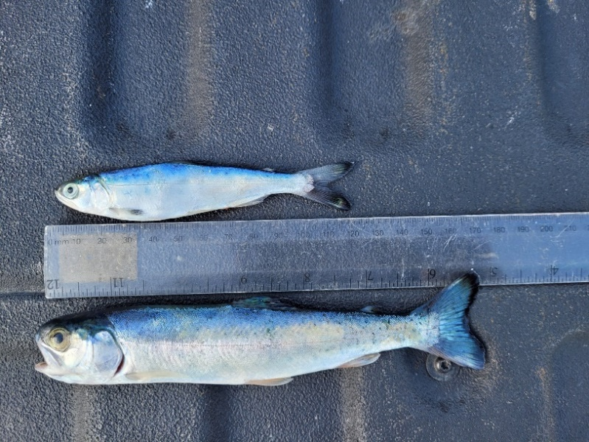 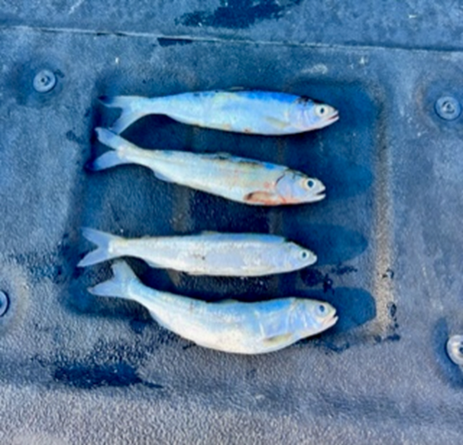

Figure 1: Steelhead smolt (~165mm FL) and sockeye smolt (~110mm FL) (left) and 3 clipped Chinook and 1 unclipped sockeye (right) recovered from tailrace deck near Spillbay-20.

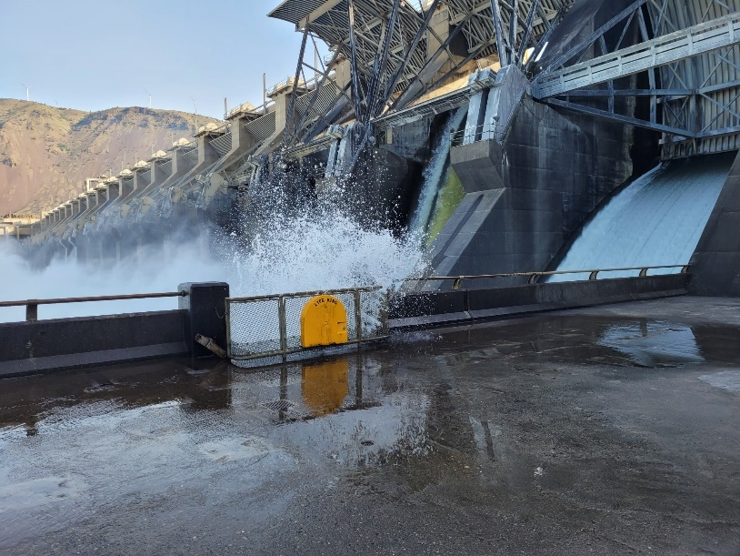

Figure 2: Image of water splashing onto the tailrace deck.

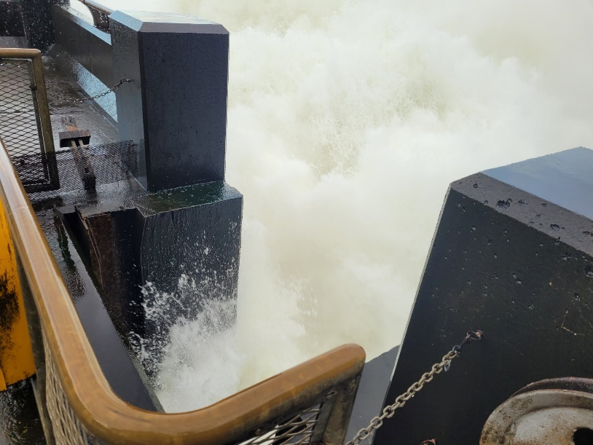

Figure 3: Location of old entrance weir within spillbay 20 discharge.

Sincerely,

JDA Project Fisheries